A discrepant event for a sixth grade classroom

The Lunar Diet

Materials required
- A copy of the story for each student

Safety and ethical consideration
- None

Place in the Manitoba Middle Years Curriculum
- Grade 6, Cluster 4: Exploring the Solar System
- 6-4-11: Recognize that mass is the amount of matter in an object, that weight is the force of gravity on the mass of an object, and that the force of gravity varies from planet to planet.

Commentary
● Narrative discrepant event can be found on pages 4 -- 9.

Bloom’s Taxonomy discussion questions
- Knowledge
Define mass and weight
- Comprehension
Discuss what caused the decreased weight on the moon
- Application
Calculate how much you would weigh on the following planets: Jupiter (gravity factor= 2.307), Pluto (gravity factor=0.041) and Venus (gravity factor=0.907)
- Analysis
Explain how the mass of an object can change
- Synthesis
What may happen to someone's weight if they were to weigh themselves on a planet where the force of gravity is similar to that of the earths?

References
This narrative discrepant event was entirely written by Angela Silla with assistance from the following sources:

- http://www.edu.gov.mb.ca/k12/cur/science/found/5to8/6c4.pdf

- http://www.fotosearch.com/bthumb/CRT/CRT465/15476-64dg.jpg

- http://www.burrface.com/image/scope_clip_art.gif

- http://school.discoveryeducation.com/clipart/images/a1school.gif

- http://upload.wikimedia.org/wikipedia/commons/f/f6/Moon_Earth_Comparison.png

- http://www.clipartof.com/images/clipart/thumbnail2/13726_astronaut_in_a_pressure_suit_floating_in_space.jpg

- http://www.lamkincounselors.com/sitebuildercontent/sitebuilderpictures/.pond/clip_art_moon.jpg.w180h179.jpg

- http://www.websitesandsoundbites.com/Question_Mark_1.gif

- http://www.clker.com/cliparts/3/4/a/d/11949855891733629502arrow-down-blue_benji_pa_01.svg.hi.png

- http://www.covillaud.mjusd.k12.ca.us/album/kid_clipart_boy.gif

- http://upload.wikimedia.org/wikipedia/commons/f/f6/Moon_Earth_Comparison.png

The Lunar Diet
In the classroom


Mrs. Vera could barely swallow her morning coffee as she was so excited to share the great news with her grade six students. She impatiently paced around the classroom as her 11 students took their time strolling into class on their first day back from the winter break. After the morning bell rang and each student took a turn sharing what they did over the break, she took a deep breath and cleared her throat as she prepared to share the news. "Class, over the break our grade six class received a very special gift from a generous man named Mr. Richman. He attended this very elementary school long ago when he was young like you. He always remembered this school because he credited it for sparking his love of astronomy, which lead to his career as a world famous astronomer. During his successful career, he wrote eight books, spoke in many countries around the world, owned his own spaceship and took part in several expeditions into space. Unfortunately, Mr. Richman suddenly passed away over the break. Class, in his will he left our us a very special gift…a field trip for all of us to the moon on his spaceship!. Class get ready because in exactly a week from today, January 17th 2105, we are going to the moon!"
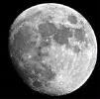

The following week in science class was spent learning as many facts as they could about the moon for their trip such as: the moon's diameter is about a quarter of the earth's diameter, the average day temperature on the moon is 107°C and the average night temperature is -153°C, the moon has no atmosphere and very importantly, the moon's gravity is one-sixth of the earth's, etc. The students absorbed all this information like sponges because they were so interested in learning about the place they were about to visit.

Finally, a few days before the departure, Mrs. Vera had all the students weigh themselves on the classroom scale and write their weight down so that she could fit them for a spacesuit.
Matthew | 80 lbs
Carla | 82 lbs
Brittney | 72 lbs
Amy | 68 lbs
Samantha | 65 lbs
Ryan | 67 lbs
Mark | 78 lbs
Blake | 68 lbs
Chelsea | 73 lbs
Martin | 77 lbs
Christine | 81 lbs
Mrs. Vera | 145 lbs

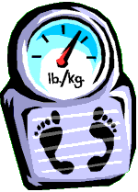
"Class, the spacesuits are to protect us on the moon, without them we could not survive up there. They will help us maintain the same pressure inside of our bodies, keep our body temperature regular, shield us from different types of radiation, and many other things. No wonder each spacesuit weights so much!" Matthew, a student in the class, blurted out "whoa, we are going to weight so much more up there with our spacesuits on. I will weigh as much as my big dad does!" Mrs. Vera realized that Matthew's comment would make for a great teaching moment once they were on the moon. Keeping in mind the science unit which was coming up for her grade six students after their fieldtrip, she packed the scale and the paper with the student's weights in her space bag.

On the moon
The students had a very eventful and fun day on the moon. Their day began with a tour of the side of the moon that faces earth, the near side. On the near side they visited the lunar plains called maria, Latin for “seas”. Mrs. Vera gave the students a lot of free time to walk around and explore the deserted area. Next, they were off to see the impact craters, the ancient remains from when the asteroids collided with the moon’s surface long ago. The students had a lot of fun jumping inside of the craters. Their last stop was the far side of the moon, where they took a

tour of some of the many terrae, Latin for “highlands”. There, they took a group picture in front of the large mountain range. “Students, we have to start making out way back towards the spaceship now. I am sad to say it, but our time on the moon is almost done”. Mrs. Vera turned around and started leading her students towards the spaceship in the distance. 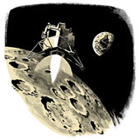

As the students were slowly jumping and bouncing their way towards the spaceship, it occurred to Mrs. Vera to pull out her scale from her space bag. She placed it just in front of the entrance to the spaceship and said to her students "I have one final thing that I need you guys to do before we get back on the spaceship. I would like each of you to weight yourselves and write down how much you weigh next to your name." Mrs. Vera lead by weighing her self first, then recording her weight next to her name. Before the first student proceeded to weigh herself, Mrs. Vera said "on earth I weigh 145 lbs, now on the moon I weigh 39 lbs". Right away the questions started "but Mrs. Vera how can you weigh less? You should weigh more with that big spacesuit on!" exclaimed Samantha. As each student weighed himself or herself, there were more and more questions as the students became increasingly curious about why each of them weighs less on the moon.

Matthew | 89 lbs (EARTH) | 30 lbs (MOON)
Carla | 82 lbs (EARTH) | 29 lbs (MOON)
Brittney | 70 lbs (EARTH) | 27 lbs (MOON)
Amy | 68 lbs (EARTH) | 26 lbs (MOON)
Samantha | 60 lbs (EARTH) | 25 lbs (MOON)
Ryan | 70 lbs (EARTH) | 27 lbs (MOON)
Mark | 82 lbs (EARTH) | 29 lbs (MOON)
Blake | 63 lbs (EARTH) | 26 lbs (MOON)
Chelsea | 73 lbs (EARTH) | 27 lbs (MOON)
Martin | 82 lbs (EARTH) | 29 lbs (MOON)
Christine | 70 lbs (EARTH) | 27 lbs (MOON)
Mrs. Vera | 145 lbs (EARTH) | 39 lbs (MOON)


"How much did you weigh on earth Carla?" asked Amy, "I weighed 82 lbs on Earth and now I only weigh 29 lbs!". "I know!" replied Amy, "I weigh only 27 lbs now, on earth I was 68 lbs. I love this lunar diet!" Some students even went back to the scale and weighed themselves 2 or even 3 times! "Maybe the scale is broken?" ask Matthew "nope, it is working just fine" replied Mrs. Vera. "But I look the same, I feel the same, my clothes are not baggier, I couldn't lose 59 lbs in a few hours" exclaimed Brittney. The students were so puzzled by what was taking place that they even tried weighing a few of each other at once, but the scale went up only slightly!

In the spaceship
Once all the students were strapped into their seats and the spaceship safely took off, Mrs. Vera decided to spend part of the voyage to earth talking about the differences in weight. "We are lucky today because we only have a 45 minute journey back to the earth ahead of us. What used to take more than a day around a hundred years ago now takes us less than an hour with our advanced technology. So, I will have more than enough time to explain what you are all puzzled by right now: why you weigh less on the moon". There was a silence amongst the students as they all paid careful attention to Mrs. Vera's explanation because they had wanted to hear it so badly. To begin with, she told them that there is a difference between mass and weight: mass is the amount of matter or particles that an object has whereas weight is the force that gravity has on the object. The downward pull of gravity is called the gravitational force, and it varies depending on the planet or moon that you are on. In other words, on some planets and on the moon, the gravity there is not pulling humans down with as much force as the
gravity on the earth is.

 moon earth

Basically" said Mrs. Vera "your mass did not change from when you were on the earth to when you were on the moon, with the exception of the extra 40 lbs of mass added to you of the spacesuit. You were still as big
or as small on the moon as you were on earth.

Matthew on earth Matthew on the moon

What did change was the gravitational force which is the pull that gravity had on you. The gravity of the moon is less than the gravity of the earth, to be exact it is one-sixth less. This is because the moon is much smaller
than earth.

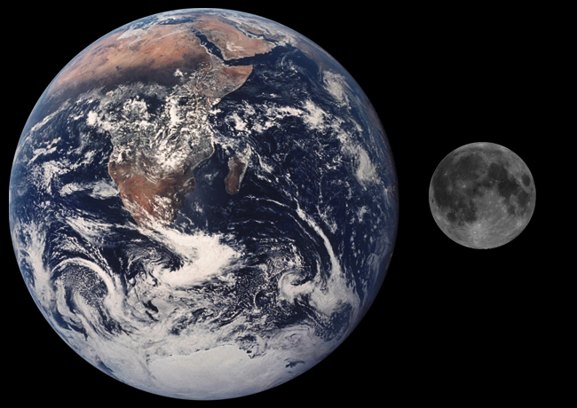

This is why you weighted less on the moon, because the gravity of the moon was not pulling you down as hard onto the scale". She gave the students another example to make it more clear "remember how high you guys were jumping on the moon and how slowly you came down from your 15 foot high jumps? Well, you were coming down so slowly because the gravity on the moon is much less than the gravity on earth. On earth, you would land much faster". Mrs. Vera began to notice the long yawns of her little astronauts; they had a very eventful day on the moon. She decided to end her explanation there and let her students enjoy the spectacular view of outer space from high above the earth.



